Experiment - 2

**Data Flow Diagram (DFD)**

The data flow inside information systems is depicted by a data flow diagram (DFD). Both expert and non-technical users can comprehend the graphical depiction of a system's data flow that Data Flow Diagrams (DFD) offer. The models make it possible for users, clients, and software engineers to collaborate efficiently when analyzing and defining requirements.

**Levels of Data Flow Diagram (DFD)**

Data Flow Diagram (DFD) uses hierarchy to maintain transparency thus multilevel Data Flow Diagram (DFD’s) can be created. Levels of Data Flow Diagram (DFD) are as follows:

**0-level DFD**

Another name for it is a context diagram. It is intended to be an abstract perspective that depicts the system as a single process together with its connections to other things. Incoming and outgoing arrows indicate input and output data, while the entire system is represented as a single bubble.

**1-Level DFD**

By dividing the main processes found in the level 0 DFD into smaller processes, this level offers a more thorough understanding of the system. The level 1 DFD shows each sub-process as a distinct process. Each sub-process's data storage and data flows are also displayed. The context diagram is broken down into several bubbles or processes in 1-level DFD. At this level, we deconstruct the high-level process of 0-level DFD into smaller processes and emphasize the system's primary functions.

**2-level DFD**

By decomposing the sub-processes found in the level 1 DFD into even more sub-processes, this level offers an even more thorough understanding of the system. The level 2 DFD shows each sub-process as a distinct process. Each sub-process's data storage and data flows are also displayed.

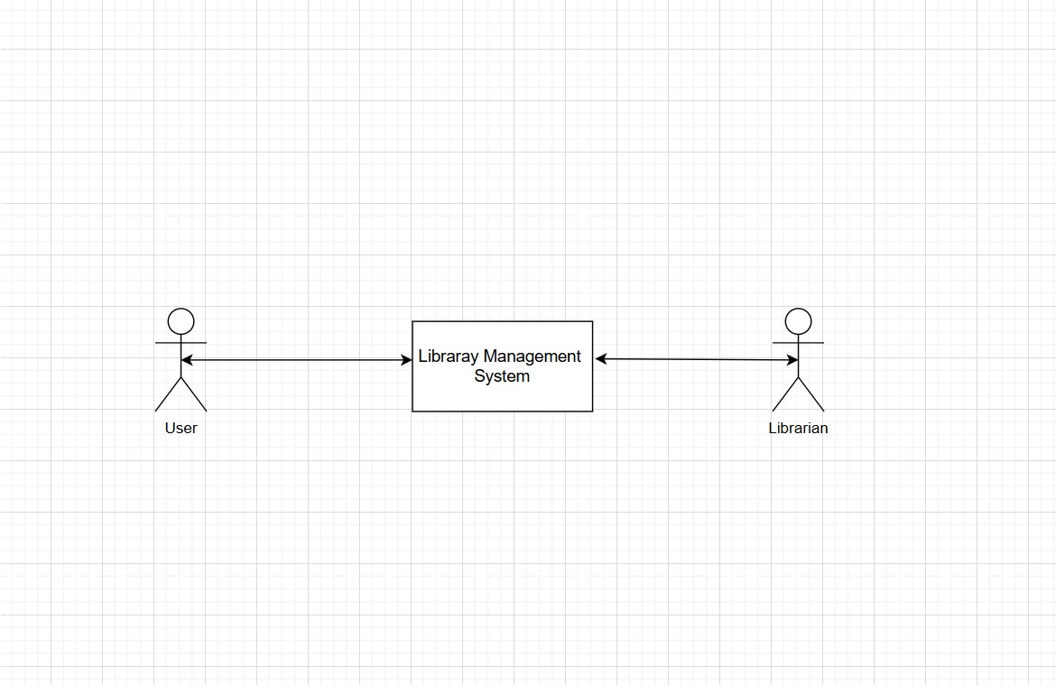

Level 0 DFD

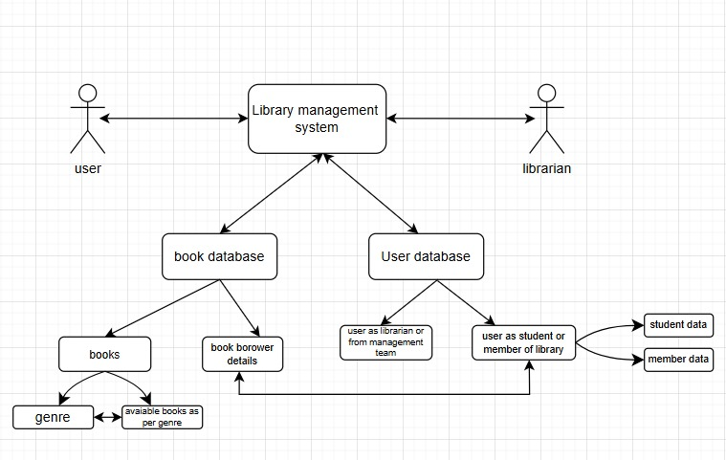

Level 1 DFD

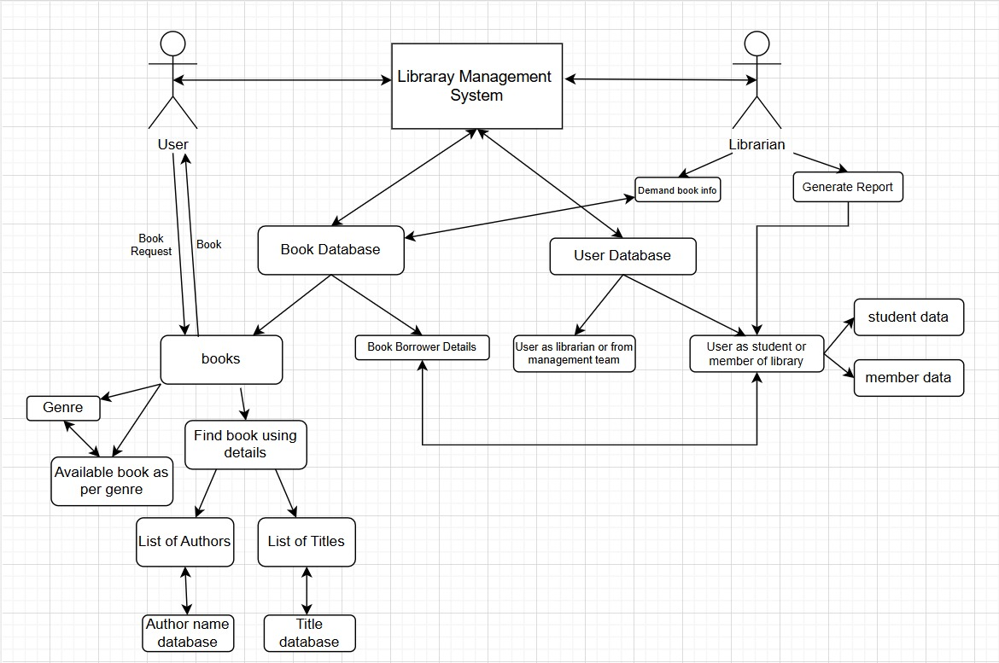

Level 2 DFD